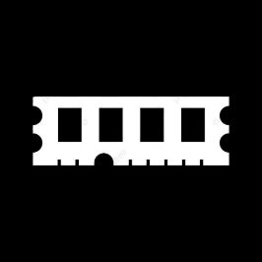

Price:226.34 2226.34$226.34

Redmi Note 13 Pro

* Processor: Qualcomm SM7435-AB Snapdragon 7s Gen 2 (4 nm)
* Front Camera: 16 MP
* Rear Camera: 200 MP
* Display:6.67 “
* NFC: Yes
* ColorsMidnight Black, Aurora Purple (Coral Purple), Ocean Teal, Arctic
* Operating System:
* Android 13
* Charging Type:
* USB Type-C
* SIM: Nano-SIM,E SIM
* Fingerprint: Yes
* Release Date: 2023, September 21

RAM

16

GB

ROM

512

GB

BATTERY

5100

mAh



+001-28272300-2466-2469



webmaster@cellinfo.com



A-65, ACME Co. ,

Street No. 12,

New York

Ask Me Ltd.